Noel Mercado

Mr. Adamo

CS210

2/24/2024

7-3 Project Three

1. How the Program Thinks**:** Think of the program as a super organized friend called ItemTracker. This friend keeps track of all the items people buy and how many times they buy them. It uses a special map to remember everything like a shopping list.

2. Understanding the Grocery List: The program reads a special list called CS210_Project_Three_Input_File.txt which is like the grocery list. Each line in the list represents one item that someone bought. The program reads through this list and counts how many times each item appears.

3. Talking to the Program: When you run the program, it talks to you through a menu. You can ask the program to do different things, like telling you how many times people bought a specific item or showing you a cool graph of all the items and how many times they were bought.

4. What the Program Can Do:

Find Items: You can ask the program to find how many times people bought a particular item, like "Apples" or "Broccoli."

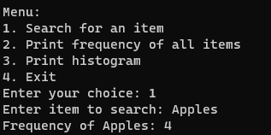

List Frequencies: The program can also show you a list of all the items and how many times each one was bought.

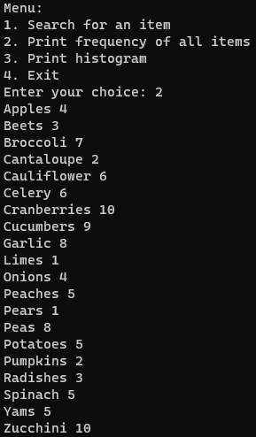

See the Graph: If you like visual stuff, the program can draw a graph for you. It uses little stars to show how many times each item was bought. The more stars, the more popular the item.

